

An Undergraduate Internship/Project on ‘Accounting System’ at Accomium

By

**Asif Nahyan Kabir**

Student ID: **1610596**

**Spring, 2022**

Supervisor:

Mohammad Noor Nabi

Senior Lecturer

*Department of Computer Science & Engineering*

*Independent University, Bangladesh*

***May 12, 2022***

*Dissertation submitted in partial fulfillment for the degree of*

*Bachelor of science in computer science*

*Department of Computer Science & Engineering*

***Independent University, Bangladesh***

**Attestation**

12.05.22

|  |  |  |
| --- | --- | --- |
| Signature |  | Date |
| Asif Nahyan Kabir |  |  |
| Name |  |  |

**Acknowledgement**

*First of all, I would like to thank our Supreme Lord Allah (SWT), for his grace in completing my internship report timely.*

*I would like to express my thankfulness to the Faculty of Computer Science and Engineering department to keep internship credit in the module of the graduation program that gave me a chance to experience professionalism, punctuality and challenges. I would like to express my appreciation to my supervisor, Mr. Mohammad Noor Nabi, Senior Lecturer, Department of Computer Science and Engineering, School of Engineering, Technology & Sciences, Independent University, Bangladesh, who inspired and showed me with his constant counsel, valuable instructions, recommendation and thoughtful advice during this dangerous pandemic pursuing this internship and preparation of this report.*

*I am also thankful to my office supervisor Mr. Rajib Hossain Pavel Sir, Chief Technical Officer (CTO) and my respective colleagues from the bottom of my heart for their assistance, tips, supervision, instructions and advice as well as for motivating me to do the internship smoothly at Accomium.*

*I feel lucky that I was always held under supervision of the Web Application Development team and got advice directly from Mr. Rajib Hossain Pavel sir. Here, with regular reporting through rational and professional help, it unleashed my experience in the internship life.*

*Moreover, to prepare this report and other documentation relating Internship Report and else I would show appreciation to all the members of Accomium team, who always advised me and helped me through hands and pens. Moreover, I must mention the wonderful working environment and group commitment of this organization that has prepared me to deal with a lot of things.*

*Last but not the least, I would like to thank my mother and few friends for their long-lasting inspiration given to me.*

*Letter of Transmittal*

*Mr. Mohammad Noor Nabi*

*Senior Lecturer*

*Department of Computer Science and Engineering*

*School of Engineering, Technology & Sciences*

*Independent University, Bangladesh*

*Subject: Submission of Internship Report for the completion of Graduation.*

*Dear Sir,*

*I am herewith submitting my Internship Report, which is a part of the Bachelor Program in Computer Science and Engineering module. It was great to work under your overseeing. This report is established on, Accounting System at Accomium. I have got the chance to work at Accomium for three months, under the supervision of Mr. Rajib Hossain Pavel Sir, Chief Technical Officer, Accomium.*

*This internship has provided me both academic and hands on practices. The internship has given me the occasion to build a network with the corporate surrounding. I attempted to make this report as much descriptive as possible with the knowledge I have acquired during my internship interval. In order to prepare a well assembled internship report, I have followed the requirements and described the required fields with enough details. I, however sincerely believe that this report will serve the purpose of my internship program.*

*I shall be highly obligated if you are kind enough to receive this report and provide your valuable verdict. It would be my great happiness if you find this reports useful and descriptive to have a clear view on the issue.*

*Sincerely Yours,*

*Asif Nahyan Kabir*

*ID- 1610596*

*Department of Computer Science and Engineering*

*Independent University, Bangladesh*

**Evaluation Committee**

.....................................................................

Signature

.....................................................................

Name

.....................................................................

Supervisor

.....................................................................

Signature

.....................................................................

Name

.....................................................................

Internal Examiner / Panel Member

.....................................................................

Signature

.....................................................................

Name

.....................................................................

External Examiner / Organizational Supervisor

.....................................................................

Signature

.....................................................................

Name

.....................................................................

Head of the Department / Convener

# *Abstract*

*This report documents the procedure of making, developing and testing a system to be used in an online accounting software solution “Acoomium”. Accomium is an online accounting software solution, Run things smoothly, keep data clean, and make acceptance a easily.*

*Changing files to Vue-js in Nuxt-Js framework. Then Zod authenticates the forms. After that, Data passing inspecting through the console, paging of all pages, making abstracts for those forms and making Laravel API to fetch the data from database and showing the data in list. The web technologies have been managed under the back-end development using Vue-js, Nuxt-js, Zod validation, PHP, database management using Laravel API.*

# Contents

|  |  |  |  |
| --- | --- | --- | --- |
| Attestation | | | i |
|  | Acknowledgement | | ii |
|  | Letter of Transmittal | | iii |
|  | Evaluation Committee | | iv |
|  | Abstract | | v |
| 1 | **Introduction** | | 1 |
|  | 1.1 | Overview/Background of the Work . . . . . . . . . . . . . . . . . . . . . . . . . . . . . . . . . | 1 |
|  | 1.2 | Objectives . . . . . . . . . . . . . . . . . . . . . . . . . . . . . . . . . . . . . . . . . . . . . . . . . . . . | 1 |
|  | 1.3 | Scopes . . . . . . . . . . . . . . . . . . . . . . . . . . . . . . . . . . . . . . . . . . . . . . . . . . . . . . | 1 |
| 2 | **Literature Review** | | 2 |
|  | 2.1 | Relationship with Undergraduate Studies . . . . . . . . . . . . . . . . . . . . . . . . . . . | 2 |
|  | 2.2 | Related works . . . . . . . . . . . . . . . . . . . . . . . . . . . . . . . . . . . . . . . . . . . . . . . . . | 2 |
| **3 Project Management & Financing** | | | 3 |
|  | 3.1 | Work Breakdown Structure . . . . . . . . . . . . . . . . . . . . . . . . . . . . . . . . . . . . . . . | 3 |
|  | 3.2 | Process/Activity wise Time Distribution . . . . . . . . . . . . . . . . . . . . . . . . . . . . . . | 3 |
|  | 3.3 | Gantt Chart . . . . . . . . . . . . . . . . . . . . . . . . . . . . . . . . . . . . . . . . . . . . . . . . . . . . | 3 |
|  | 3.4 | Process/Activity wise Resource Allocation . . . . . . . . . . . . . . . . . . . . . . . . . . . . | 3 |
|  | 3.5 | Estimated Costing . . . . . . . . . . . . . . . . . . . . . . . . . . . . . . . . . . . . . . . . . . . . . . | 3 |
| 4 | **Methodology** | | 4 |
| **5 Body of the Project** | | | 5 |
|  | 5.1 | Work Description . . . . . . . . . . . . . . . . . . . . . . . . . . . . . . . . . . . . . . . . . . . . . . . . | 5 |
|  | 5.2 | Requirement Analysis . . . . . . . . . . . . . . . . . . . . . . . . . . . . . . . . . . . . . . . . . . . . | 6 |
|  | 5.3 | System Analysis . . . . . . . . . . . . . . . . . . . . . . . . . . . . . . . . . . . . . . . . . . . . . . . . | 6 |
|  |  | 5.3.1 Six Element Analysis . . . . . . . . . . . . . . . . . . . . . . . . . . . . . . . . . . . . . . . . | 6 |
|  |  | 5.3.2 Feasibility Analysis . . . . . . . . . . . . . . . . . . . . . . . . . . . . . . . . . . . . . . . . . . | 6 |
|  |  | 5.3.3 Problem Solution Analysis . . . . . . . . . . . . . . . . . . . . . . . . . . . . . . . . . . . . | 6 |

5.3.4 Effect and Constraints Analysis . . . . . . . . . . . . . . . . . . . . . . . . . . . . . . . . 6

|  |  |  |  |  |
| --- | --- | --- | --- | --- |
| CONTENTS | | | CONTENTS | |
|  | 5.4 | System Design …………………………………… | ……………………….................... | 6 |
|  | 5.5 | Implementation …………………………………… | ..................................................... | 6 |
|  | 5.6 | Testing ……………………………………………**.** | .................................................... | 6 |
| 6 | **Results & Analysis** | |  | 7 |
| 7 | **Project as Engineering Problem Analysis** | |  | 8 |
|  | 7.1 | Sustainability of the Project/Work ……………… | ..................................................... | 8 |
|  | 7.2 | Social and Environmental Effects and Analysis | .................................................... | 8 |
|  | 7.3 | Addressing Ethics and Ethical Issues ………… | ..................................................... | 8 |
| 8 | **Lesson Learned** | |  | 9 |
|  | 8.1 | Problems Faced During this Period ……………. | ..................................................... | 9 |
|  | 8.2 | Solution of those Problems ……………………. | ..................................................... | 9 |
| 9 | **Future Work & Conclusion** | |  | 10 |
|  | 9.1 | Future Works …………………………………….. | ..................................................... | 10 |
|  | 9.2 | Conclusion …………………………………….… | …………………..………………… | 10 |
|  | **Bibliography** …………………………………………… | | …………………………………….. | 11 |

vii

# ***Chapter 1***

## ***INTRODUCTION***

*Keeping a good view of the growth and use of web, we planned to create the web app that is “Accomium”. In this project, An online accounting software solution has been created from physical to website based. This online accounting software solution will liberate time by organizing bills & expenses, invoicing & easy settlement all at one point. Create clear active statements and get reports, the way a client like them.*

## ***Project Background***

*Conventional Accounting Software comes with existing foundation costs as well as conservation costs of onsite software and hardware. Accomium, on the other hand, supplies a software function without large in advance costs or authorizing fees. Online Accounting software solution not only operates data and makes reports much quicker than physical systems, but also permits quicker record entry. Generally Online Accounting software solution will save you a lot of time, as it allows papers such as invoices, purchase orders and payroll to be gathered and printed swiftly and precisely.*

## ***1.2 Problem Statement***

*In conventional management accounting, the root aim was to examine, sum up, and record costs and organizations were not searching cost behavior, drivers, and variations. In today’s regulating accounting, the aim is to save, sum up, and examine costs and examine the cost behavior, drivers, and variations through Accounting System.*

*Accomium is an instrument useful to record the run a company's money and inspect monetary state. With it, transactions can be saved, reports can be provided, direct customer and vendor contacts, create purchase orders, track stock levels, bill customers, and keep track of account balances.*

## *Objectives*

* *Saving data.*
* *Measuring Profit/loss.*
* *Ready financial statement.*
* *Realize financing requirements of the business.*
* *Cash flow regulation.*
* *Regular announcing and financial examinaion.*
* *Business estimate.*
* *Filing taxes.*

## *Scopes*

* *Password changing option.*
* *Create user to recover features about the user’s identification.*
* *Edit, get details about the user’s identification.*
* *Observing and running business deal & reports.*
* *Identifying and preventing mistakes.*
* *Easy communication with stakeholders.*
* *Safe secure intuitive data.*
* *Run all payroll with appropriate details.*

# *Literature Review*

## ***Relationship with Undergraduate Studies***

*In Independent University Bangladesh (IUB), I had some courses related to my internship work, Web Application & Internet (CSC455), System Analysis and design (CSC405) and Software Engineering (CSC445).*

* *CSE101: Introduction to Computer Programming. This module was taught to grasp basic knowledges from creating illustrations, if-else, different types of loops, intro to arrays (2D, 3D) and functions.*
* *CSE 203: Data Structure. This module was taught how to grasp and operate complex arrays, objects, classes, array of objects, objects of array, nested arrays, nested objects, etc. As Accounting System involves many complex data structures, the expertise earned from this module made me manage them much easier.*
* *CSE 213: Object-Oriented Programming. This module is a huge jump into classes and its objects of programming. It also taught how to write modular pro-grams which made codes less tedious and more useful. It assisted to plan Accounting System code in a modular format. Also, as the application grew bigger, this practice helped avoid writing new modules from scratch by using parts of old modules and adding new functions to them.*

*CSE 303: Database Management. This module was taught how to plot and plan a project. It covered popular planning and strategy practices such as System Development Life Cycle, Rich Picture, Requirement Analysis, Entity Relationship Diagram, Business Process Model and Notation Diagram and many more. These techniques helped in the development planning and strategy of Accomium.*

## ***INSTRUMENTS THAT HELPED US TO BUILD THIS PROJECT***

## 

## ***Laravel***

*With the rise of mobile development and JavaScript frameworks, using a Restful API is the best option to build a single interface between your data and your client.* ***Laravel*** *is a PHP framework developed with PHP developer productivity in mind.*

**

## ***Vue.js***

*Vue.js is an open-source model–view–view model JavaScript framework for building user interfaces and single-page applications.*

**

## ***Nuxt.js***

*Nuxt.js is a free and open source web application framework based on Vue.js, Node.js, Web pack and Babel.js. The framework is advertised as a "meta-framework for universal applications".*

**

## ***Related works***

*Most of the landing pages we use vue.js tailwind css for their development. As our goal for this project is develop the web server, we used more complex development frameworks. It is challenging to find a related website that has used similar web technologies to our project. Some websites in the industry are stated below*

* **Xero Accounting Software:** Xero accounting software is an online accounting software, Xero accounting software is for small businesses, accountants, and bookkeepers. It connects small business owners with their numbers, their bank, and advisors. Founded in 2006, They have over 3 million subscribers and leads the cloud accounting market in New Zealand, Australia and the UK.
* **Book Keeper:** Book Keeper Windows is a complete accounting + inventory management software designed especially for Windows. Create estimates and invoices, receipts & payments, record expenses, bills and purchases, Banking/Journal vouchers and view over 35+ financial reports.
* **Zoho Book:** Zoho Books is online accounting software that manages your finance, automates business workflows, and helps you work collectively across departments. This is an end-to-end accounting system, easy collaboration & integrated platform.
* **FreshBooks:** FreshBooks is the darling of small contract-based businesses and provides a good option for any self-employed business owner, freelancer, or other small businesses. It is known for its ease of use and strong invoicing functionality

These are some ongoing projects similar like Accomium.

# Project Management & Financing

## Work Breakdown Structure

## Process/Activity wise Time Distribution

*The evaluated time needed to finish a project with favorable time distribution. This assists the contributors to make a plan as to how accurately they need to effort in order to meet the time limit. Most importantly in correctly scheming an application within the time supervision. Fixing the content first, and contributions must be based on factors. The method of designing and managing how much time to go through on many tasks is known as time supervision. Good time supervision lets a person to do more in less time, reduces pressure, and steers to executive success. Time distribution is very much required to perfect any project.*

|  |  |  |  |
| --- | --- | --- | --- |
| Index | Activity description | Start & End | Duration |
| A | Proposal | Oct 12 - Oct 13, 2021 | 2 days |
| B | Acceptance | Oct 14 - Oct 16, 2021 | 3 days |
| C | Planning | Oct 17 - Oct 20, 2021 | 4 days |
| D | Cost & Schedule | Oct 21- Oct 23, 2021 | 3 days |
| E | Design | Oct 24 - Nov 23, 2021 | 30 days |
| F | Development | Nov 24 - May 27, 2022 | 6 Months |
| G | Testing | May 28 - Jun 7, 2021 | 10 days |
| H | Deployment | Oct 2021 – Jan 2023 | In entire phasing |

## Gantt Chart



## Process/Activity wise Resource Allocation

*Resource allotment is the procedure of setting benefits in a way that helps team’s goals. For this project, the developers are reflected as the initial resource followed by the computers used in the office, the servers required for the implementation of the project. Every worker of the company is appraised a resource; hence everyone has given a specific project with definite time limit, all of which cooperate to the entire manufacture of the project. For this project, we need total 78 days for making the entire system. Following are the details of every step of the project:*

**Project Management:** This is the initial session of the project, where the foundation of the project was made by the CTO of the company. During the first 2 weeks of the development procedure, the developers and the CTO worked together and had meetings in 72 hours of discussion of how this project should be made from top to bottom, the paths to be taken, making smaller aims and setting time limits for them and discussed thewhole requisites for the execution of the project. For example, Computer specifications, software to work with to make the application, features and contributors required. This part is exactly 14.60% of the total works.

* + - **Design:** In this period two UI/UX planners worked almost 30 days creating the web pages of the application as well as the regulation team started working on the high and low levels charts for the project in order to get a clear picture on view. This part is exactly 25.08% of the total works.
    - **Development/Coding:** At this stage, the designs for the web pages were complete and developers started working on writing the code for the front end and backend of the application, while the management team kept regulating whether all the deadlines were maintained. The whole process is going for 60 days considered 40.46% of the total works.
    - **Testing:** Testing initiated as soon as a feature was added to the website. So together the testing was being carried out by the developers. At the end of the creation phase unit testing for the application started. This procedure is going for 10 days which is 10.89% of the total works.
    - **Deployment:** After the testing was done, the team understood that it was not going to meet deadline. For deployment, a Virtual Private Server and a domain was bought to execute the application on a live server. This is going for 15 days which is almost 40 hours of works and is 8.97% of the total works.

|  |  |  |
| --- | --- | --- |
| Activity | Days | Work Percentage |
| Project Management | 15 | 14.60% |
| Design | 30 | 25.08% |
| Development/Coding | 60 | 40.46% |
| Testing | 10 | 10.89% |
| Deployment | 15 | 8.97% |
| **Total** | **135** | **100%** |

## Estimated Costing

We tried our best to finish the entire project within the costing. The first budget for this project was not more than thirty-five thousand BDT. And we could not cover the work within the budget.

Following is the Table that shows the estimation of the project:

|  |  |
| --- | --- |
| **Work Distribution** | **Costing** |
| Front-End Development | 40000 |
| Back-End Development | 120000 |
| Hosting | 15000 |
| Miscellaneous Expense | 10000 |
| Total | 1,85,000 |

# Methodology

The study mainly focuses on the development of online accounting software solution for small businesses. To develop the website we followed Waterfall Methodology.

The waterfall model is a breakdown of project activities into linear sequential phases, where each phase depends on the deliverables of the previous one and corresponds to a specialization of tasks. The approach is typical for certain areas of engineering design. The waterfall methodology is a sequential development approach, in which development is seen as flowing steadily downwards (like a waterfall) through several phases.

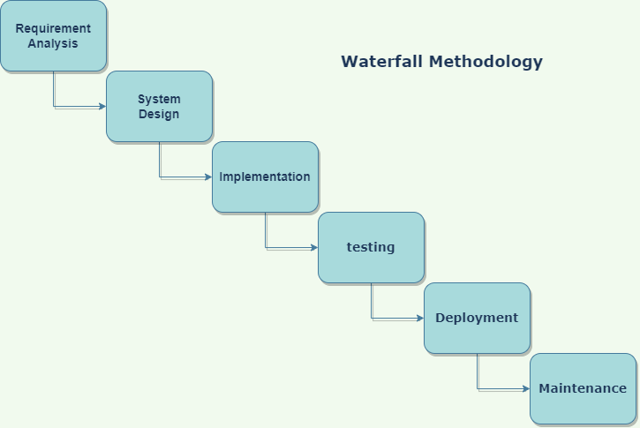

Figure 4 : Waterfall Model

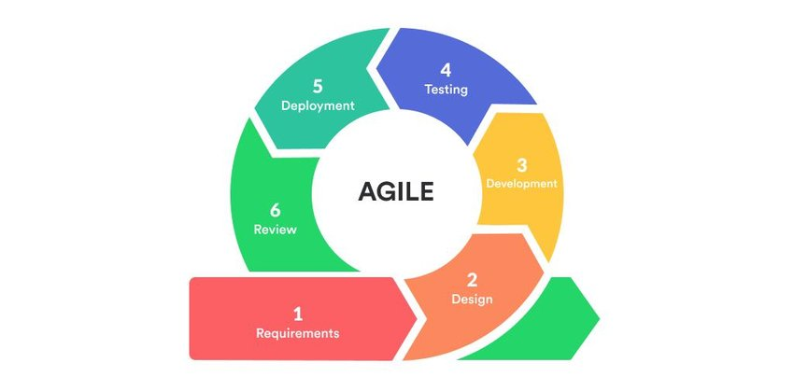

Figure 4 : Agile Model

**Reasons for choosing Agile methodology :**

* + 1. **Faster time to market:** Heaps of people that choose to go lithe are pretty tired of multi month delivery cycles that frequently convey an inappropriate item to showcase and our clients simply aren’t keen on purchasing. The possibility of two weeks’ delivery cycles and quarterly release cadences is quite engaging. Our business sectors and our opposition are simply moving excessively quick. So, we must show signs of improvement at getting working items out the door faster.
    2. **Clients satisfaction:** Building items our clients can utilize satisfies them. Having the option to frequent add new highlights based on their feedback makes them happy as well. As a product client, I don’t know there is anything more terrible than putting resources into an item that doesn’t work, doesn’t do what we need it to do, and not being not able to see any way ahead for improving it. Agile helps us to build good relationships with our customers, one where we are working together to get problems solved.
    3. **Build the right products:** Regardless of whether we are building the specific highlights that our clients are asking for, steady delivery encourages us to assemble them the manner in which our clients will really use them. At the point when we deliver in smaller increments, we have the chance to let our clients see the developing item, react to it, and change it as they go. Agile helps the customer and the team converge on the best possible outcome.
    4. **Early risk reduction:** Agile doesn’t regard risk as a different area to be overseen. Agile is risk management. By conveying early and getting feedback, we lessen the danger of building an inappropriate product. By ceaselessly incorporating and fabricating imperfection free programming, we decrease the risk that our stuff wasn’t constructed right not long before we have to put it up for sale to the market.
    5. **Better quality:** Agile fixes time, cost, and quality and gives us the tools to change the business and specialized extent of the arrangement. You probably won’t get all that you sought after, however you can believe what was delivered.
    6. **Efficiency:** People realize that the large forthcoming plans as a rule turn out pointless over the long run. Individuals realize that the individuals in their practical silos aren’t working very well together. Lithe holds the guarantee of helping us wipe out the stuff we don’t require and get down to the matter of building working software.

Body of the Project

## Work Description

Online accounting system Accomium is software or web-based accounting software which is hosted on a remote server.

This software applications can be acquired by users through the internet or other networks through a cloud application service provider. With a cloud-based accounting software, a company does not require to set up separate desktops with software because everyone in the company can enter the cloud on their own devices. This also permits remote teams or branches to enter the same data and the same version of the software.

A significant improvement of accounting software is the record backup and disaster r recovery.

*1. Create Account and Login*

*Actors: Customer, User and Admin*

*2. Search*

*Actors: User, Customer*

1. *See Customer Demand*

*Actors: Admin*

1. *Accept/Reject Requests*

*Actors: Admin*

1. *Payment*

*Actors: User, Customer*

1. *Get an Invoice*

*Actors: User, Customer*

## Requirement Analysis

Requirements Analysis is the process of illustrating the assumptions of the users for an application that is to be made to refine. Requirement’s inspection needs all the works that are managed to identify the requirements of various stakeholders. Hence, requirements inspection means to survey, report, authenticate and manage software or system requisites. Great standard requirements are documented, actionable, measurable, testable, traceable, helps to identify business opportunities, and are defined to a facilitate system design as well. The requirements of the company we have included functions into the system and conclude the requirements as well.

**Functional Requirement:**

The functional requirement is that it essentially specifies something a system should do. The Functional Requirements are the operations and activities that a system must be able to perform.

Here in this section Functional Requirements for the system includes:

* Descriptions of data to be entered into the system,
* Descriptions of operations performed by each section,
* Descriptions of work-flows performed by the system,
* Descriptions of system reports or other outputs,
* Who can enter the data into the system,
* How the system meets applicable regulatory requirements.

**Functional Requirement No - 01:** Compatibility

|  |  |  |
| --- | --- | --- |
| **Name of the Function:** Must be compatible with all computers having windows Operating system. | | |
| **Input**  N/A | **Process:**  Software must be developed in a common development environment. And it can’t be a web-based app only. | **Output:**  Software can be installed in windows platform and must be a laptop or desktop computer. |
| **Precondition:** User must have a Computer or Laptop which has ability to run the software. Must have Laravel 3.0 and PHP 7.2 or more. | | |
| **Post condition:** Nobody can use this software unless they are trained to use it. | | |

**Functional Requirement No - 02:** Log in:

|  |  |  |
| --- | --- | --- |
| **Name of the Function:** Login account | | |
| **Input**  User ID | **Process:**  Signing in the Software | **Output:**  View the main interfaces in the software. |
| **Precondition:** Must have internet connection and devices to communicate of the server or have database on local computer get access of this software. | | |
| **Post condition:** User can view the all the interfaces and can use the Website. | | |
| **Alternate Options:** If email or User ID and Password is not correct then showing the alert, “User ID or password is incorrect.” | | |

**Functional Requirement No - 03: Create User profile:**

|  |  |  |
| --- | --- | --- |
| **Name of the Function:** Create User Profile | | |
| **Input**  Go to user add tab | **Process:**  Fill the add user form | **Output:**  User can create new profile |
| **Precondition:** User must have to go add user page. | | |
| **Post condition:** User has to fill the forms. | | |
| **Alternate Options:** N/A | | |

**Functional Requirement No - 04: User profile:**

|  |  |  |
| --- | --- | --- |
| **Name of the Function:** User can see user profiles | | |
| **Input**  Go to list tab | **Process:**  Search by user id or Name or Scroll down | **Output:**  User can see all information of selected profile. |
| **Precondition:** User must have to go view profile page. | | |
| **Post condition:** User can see all information of selected user profile. | | |
| **Alternate Options:** N/A | | |

**Functional Requirement No - 05: Update or Delete User profile:**

|  |  |  |
| --- | --- | --- |
| **Name of the Function:** User have ability to update or delete user profile | | |
| Input  Go to list tab | **Process:**  Search by User id or Name or Scroll down | **Output:**  User can see all information of selected User. |
| **Precondition:** User must have to go view profile page. | | |
| **Post condition:** User can see all information of user profile. | | |
| **Alternate Options:** N/A | | |

**Non Functional Requirement :**

Non-functional requirements are often called "quality attributes" of a system. A non-functional requirement (NFR) is a requirement that specifies criteria that can be used to judge the operation of a system. Here, according to this website Non Functional Requirements are discussed below.

**User friendly interfaces & less response time:** Every interfaces of this website is easily understandable and user friendly. Because of containing fast speed of server users can use this website without interruption.

**Extensibility and maintainability requirements:** The website can be expanded to accommodate many further modules without making any changes to any existing modules. This website is created in such a way that the administrator can easily maintain server, agent and user sides simultaneously.

## **5.3 System Analysis**

System analysis is a problem-solving method that involves looking at the wider system, breaking apart the parts, and figuring out how it works in order to achieve a particular goal. It is applied to information technology, where computer-based systems require de- fined analysis according to their makeup and design.

* + 1. Six Element Analysis

|  |  |  |  |  |  |
| --- | --- | --- | --- | --- | --- |
| Process | System Roles | | | | |
|  | Human | Computer Hardware | Software | Databa se | Comm. & Network |
| Home Page | User | Computer/ Phone | Chrome, Firefox, Microsoft Edge, Safari | db.sqlit e3 | WAN/LAN |
| Login/ Signup | User | Computer/ Phone | Chrome, Firefox, Microsoft Edge, Safari | db.sqlit e3 | WAN/LAN |
| Bank Account | User | Computer/ Phone | Chrome, Firefox, Microsoft Edge, Safari | db.sqlit e3 | WAN/LAN |
| Bank Adjustment | User | Computer/ Phone | Chrome, Firefox, Microsoft Edge, Safari | db.sqlit e3 | WAN/LAN |
| Bank transaction | User | Computer/ Phone | Chrome, Firefox, Microsoft Edge, Safari | db.sqlit e3 | WAN/LAN |
| Bill | User | Computer/ Phone | Chrome, Firefox, Microsoft Edge, Safari | db.sqlit e3 | WAN/LAN |
| Expense | User | Computer/ Phone | Chrome, Firefox, Microsoft Edge, Safari | db.sqlit e3 | WAN/LAN |
| Fixed Asset | User | Computer/ Phone | Chrome, Firefox, Microsoft Edge, Safari | db.sqlit e3 | WAN/LAN |
| General Preference | User | Computer/ Phone | Chrome, Firefox, Microsoft Edge, Safari | db.sqlit e3 | WAN/LAN |
| Invoice Preference | User | Computer/ Phone | Chrome, Firefox, Microsoft Edge, Safari | db.sqlit e3 | WAN/LAN |

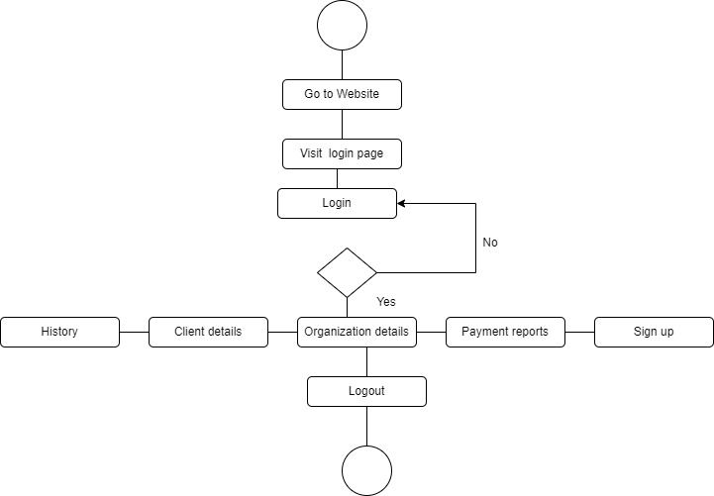

Figure: Activity diagram for Admin

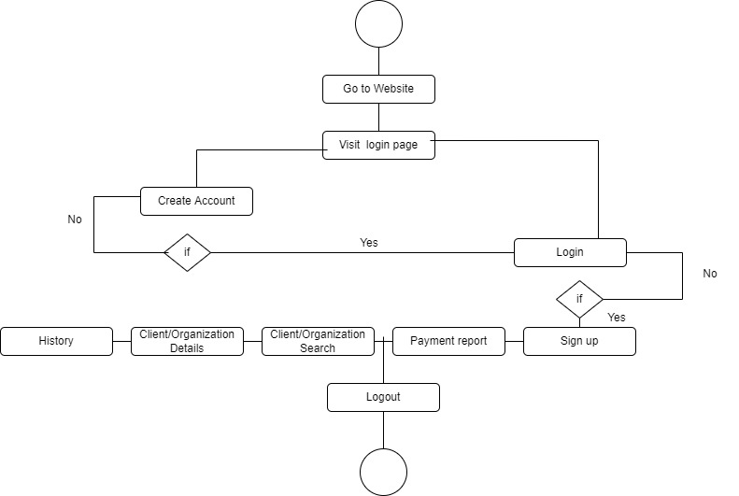

Figure: Activity diagram Client/Organization

* + 1. **Feasibility Analysis**

The analysis of a suggested project is to control even if it is feasible and should go forward is called feasibility analysis. Verification of plan and strategy is the main significance of this analysis. This can be used to authenticate expectation, constraints, decisions and approaches.

There are some main parts of feasibility analysis. They are –

* **Operational feasibility:** The website is helpful only if it is turned into information systems that will execute the company’s managing requirements. This test of feasibility asks if the system will work when it is made and positioned.
* **Technical feasibility:** The software and hardware requisites to make this website is the reviewing matter on technical feasibility. The proposed technology has to meet all software requirements by considering conditions as the browser support for PHP programming language along with basic web technologies.
* **Economic feasibility:** Appropriate budget, financial benefits, investment vs. profit are main factors for economic feasibility. There is no need for any extra man power to maintain the website. As this project was developed using open source technology no additional funding is needed for technology. This project is certainly economically feasible according to these features.
  + 1. **Problem Solution Analysis**

During the project implementation various problems occurred. We tried to solve them and implement them. For all problems we followed some basic steps. They are as follows:

* + - * **Identification:** Identifying the problem as precisely as possible.
      * **Requirements that are affected:** The project requirements that are affected by the problem.
      * **Solution:** Finding the most accurate and precise solution.
      * **Implementation:** Implementing the particular solution.
      * **Testing:** Testing if the solution solved the problem. If not then previous steps are followed again.
    1. **Effect and Constraints Analysis**

When the system wasn’t cloud based. It was difficult for the client to keep track of the all transactions and updates.

This research begins by evaluating the Accurate Online subscription process as an object of research. When choosing a software

product, all of the additional advantages and features (cost savings, convenience, increased service accounting efficiency,

mobility) must be compared with the weaknesses and threats, especially those related to privacy, trust and data security. For this

reason, a SWOT analysis can be applied by companies before choosing to use cloud accounting. Prospective users can do the

subscription process for Accurate Online independently. What is needed is to register by filling in the user's name, email address

and verification will be carried out using email or OTP sent by SMS to the number that has been registered. Accurate online

gives users the opportunity to use it for free with a trial period of 30 days. If the user is interested in using it, the potential user

will agree to the terms and conditions and make a payment. Payment can also be made by cash or using a credit card.

Users can work from anywhere. The provider automatically upgrades the software to add new features and keep up with changes to tax and accounting rules. Some cloud finance solutions also automate routine accounting processes and help ensure accuracy.

## **System Design**

Systems design is the process of defining elements of a system like modules, architecture, components and their interfaces and data for a system based on the specified requirements. It is the process of defining, developing and designing systems which satisfies the specific needs and requirements of a business or organization.

*Rich Picture*

*A rich picture is a drawing of a state that demonstrates the major constituent and connection that need to be appraised in attempting to mediate in order to create some development. It contains pictures, text, symbols and icons, which are all used to draw graphically the state. A rich picture is useful to us to see connections that we may miss. It helps recognizing one or more themes members may want to additionally traverse and address. Rich pictures are hence always used in the prior analysis phase.*

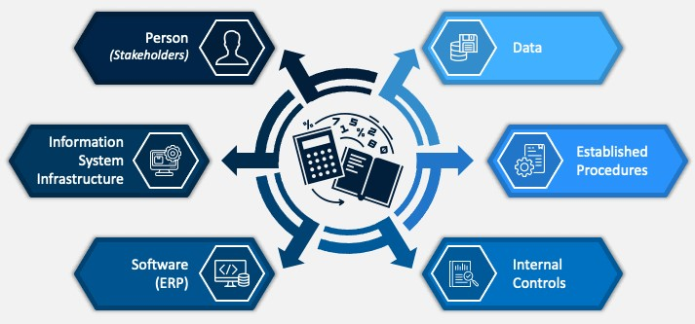

* + 1. **UML Diagram**

*A UML diagram is a diagram based on the UML (Unified Modeling Language) with the intent of clearly showing a system along with its main components, parts, activity, in order to better know, change, continue, or report details about the system. UML diagrams can be helpful as a way to observe a project before its implementation or as confirmation for a project later. But the general goal of UML diagrams is to permit groups to observe how a project is or will be in work, and they can be operated in any sector.*

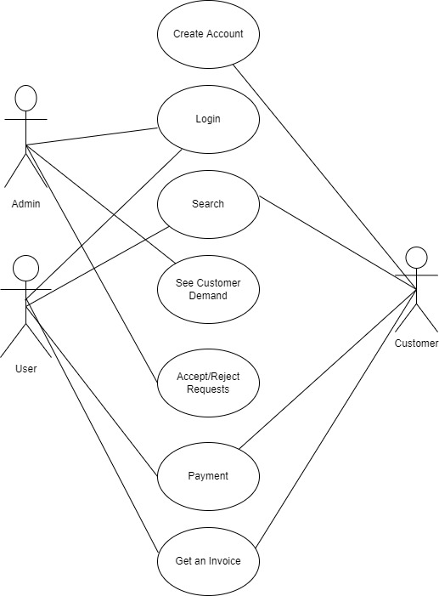

## **Implementation**

We have seen the design and analysis of Accomium. In this section we will explain how the Accomium System has been developed and the tools that have been required as well as process of configuring, coding and other system components.

**MySQL Database**

Database is used to store all the information like unique Id of the user, name, and products name for every page. It also helps to verify and identify the user and products status.

For implementing the web app we used XAMPP which is a free and open source cross platform web server solution stack package developed by Apache Friends, consisting mainly of the Apache HTTP Server, MySQL database, and interpreters for scripts written in the PHP.

In this project it has been worked through Local host, which is basically a local server that allowed hosting website online on a local IP that is visible only in this system, by connecting to web server like Apache Web Server.

After installing XAMPP and activated/started Apache HTTP server which supports a variety of features, many implemented as compiled modules which extend the core functionality. These can range from authentication schemes to supporting server side programming languages. Then by activating/starting MySQL which is helpful for database driven web applications.

**Laravel API**

Laravel API allows migrating schemas automatically by command. In this project schemas created for all specific pages that help to create database by migrating through Laravel commands. In Laravel API for each pages a controller, a model and a route has been build which is the plug in with the vue-nuxt project. By connecting laravel api and vue nuxt project with database the whole project works parallel.

API Controller handles incoming HTTP requests and sends response back to the caller. API controller is a class which can be created under the Controllers folder or any other folder under the vue nuxt project's root folder.

API routes an incoming HTTP request to a particular action method on a Web API controller.

## **5.6 Testing**

For testing this Windows application both white box and black box testing methodologies has been applied. Where white box testing is the software testing method in which internal structure is being known to tester who is going to test the software and black box testing is the software testing method which is used to test the software without knowing the internal structure of code or program. Here, the role played for developer and tester as well as UAT (user acceptance testing) also done by team member.

**INPUTS**

|  |  |
| --- | --- |
| **Inputs of Accomium** | |
| **Process** | **Fields type** |
| Login | Email- string Password- string |
| Registration | Name - string Email - string Password - string Phone - integer  Date of Birth - string Address - string |
| Bank Account | Account Type- string  Name- string  Currency code- string  Phone- integer  Address- string  Account Number-integer  Email- string |
| Bank Adjustment | Currency code- string  Bank Statement-string  Account Code- integer  Currency Rate- float  Reference- string  Amount- float |
| Bank transaction | Account Code- integer  Type- string  Date-string  Status- string  Reference- string  Contact- string |
| Bill | Order Number- integer  Adjustment amount- float  Tax amount- float  Bill Number – integer  Amount- float |

**OUTPUT**

|  |  |
| --- | --- |
| Outputs of Accomium | |
| **Process** | **Fields type** |
| Login | On success- Redirect to user dashboard.  On failure- Show error message “Please enter correct id or password”. |
| Registration | On success- Show success message “Registration successfully done!”.  On failure- Show error message “Registration not done!”. |
| Bank Account | On success- Save specific user’s information.  On failure- Show error message . |
| Bank Adjustment | On success- - Adjust specific user’s Banking.  On failure- Show error message |
| Bank transaction | On success- transaction info will be saved  On failure- Show error message |
| Bill | On success- billing status would be stored  On failure- Show error message |

**Designing Test Cases :**

|  |  |  |  |  |  |  |  |  |
| --- | --- | --- | --- | --- | --- | --- | --- | --- |
| **Test Scenario ID** | **Test Scenario Description** | **Test Case Description** | **Test Steps** | **Precondition** | **Post Condition** | **Expected Results** | **Actual Results** | **Status** |
| 01 | Verify Login functionality | Entering valid user ID & password | [1] Enter valid user ID & valid password  [2] Click on Login button | Valid Test Data | User should able to see the home page | Successful Login | As expected, | Pass |
| 02 | Verify Login functionality | Entering valid user ID & password | [1] Enter valid user ID & valid password  [2] Click on Login button | Valid Test Data | Error message as “invalid username or password” | A pop-up message to show an error | As expected, | Pass |
| 03 | Verify Login functionality | Entering invalid username & valid password | [1] Enter invalid user ID & password  [2] Click on Login button | Valid Test Data | Error message as “invalid username or password” | A pop-up message to show an error | As expected, | Pass |
| 04 | Navigation Bar functionality | Appearance of Navigation Bar | [1] Entering to any page of software | Valid test type | Navigation Bar should be appeared on screen | Navigation Bar appears | As expected, | Pass |
| 05 | Manage Hr part | Go to list page | [1] Select department  [2] Right click on mouse | Edit or delete test type | Edit or delete popup should appear | Edit a department or Delete a department | As expected, | Pass |
| 06 | Adding new Accounts part | Entering necessary Information | [1] Entering necessary information  [2] Click on add button | Account added | N/A | All Data saved to database | As expected, | Pass |
| 07 | Manage Accounts part | Go to list page | [1] Select accounts  [2] Right click on mouse | Edit or delete test type | Edit or delete popup should appear | Edit an account or Delete an account | As expected, | Pass |

# Results & Analysis

While testing the program, there were several issues. This was a minor issue that we were able to resolve. After the resolving of these issues, test cases were documented. Testing methodologies have been used to justify all test cases. We did our testing on a local server. We’ll test everything on the hosting again after it goes online. As a result, various modifications may occur at that time. There are few integrations possible. But it will be added in the future. So, all the tastings are not done. But up to the current feature available, all the testing is done, and it is running fine. But live testing with users is not done yet.

**6.1 Graphical User Interface Result**

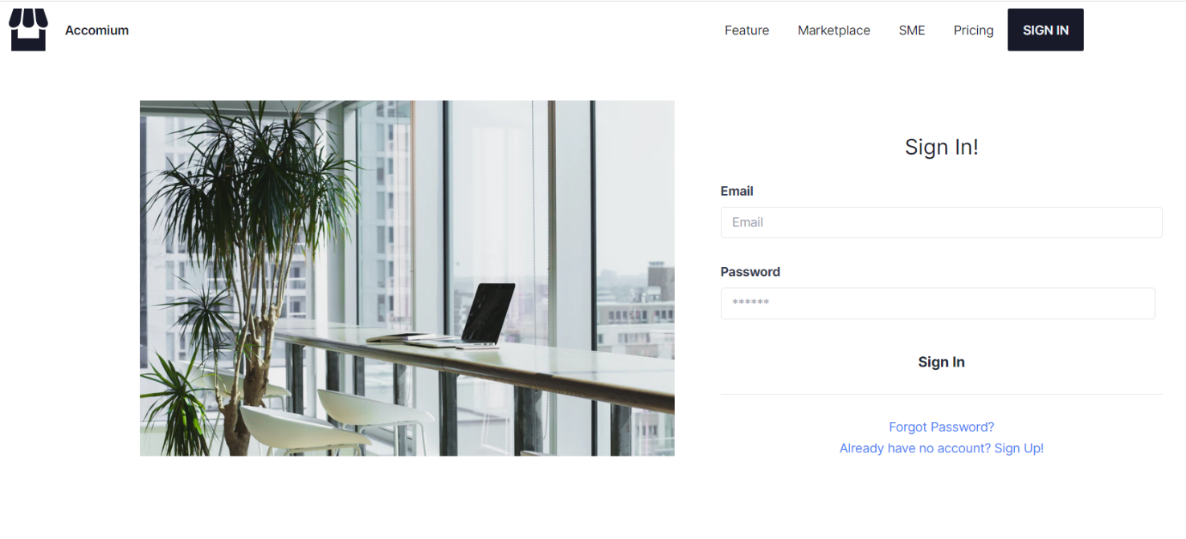

***Sign in page for user***

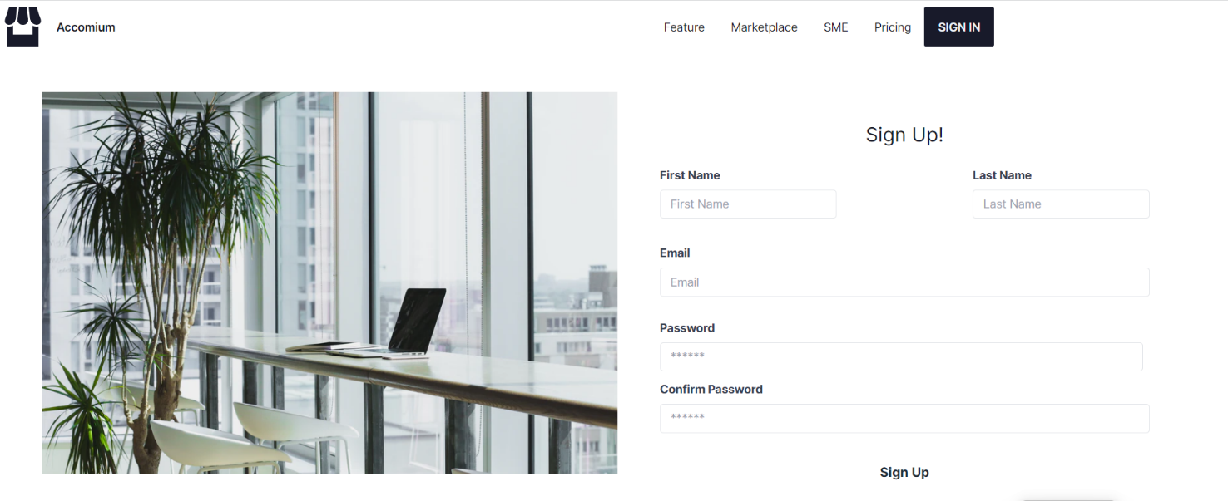

***Sign up page for user***

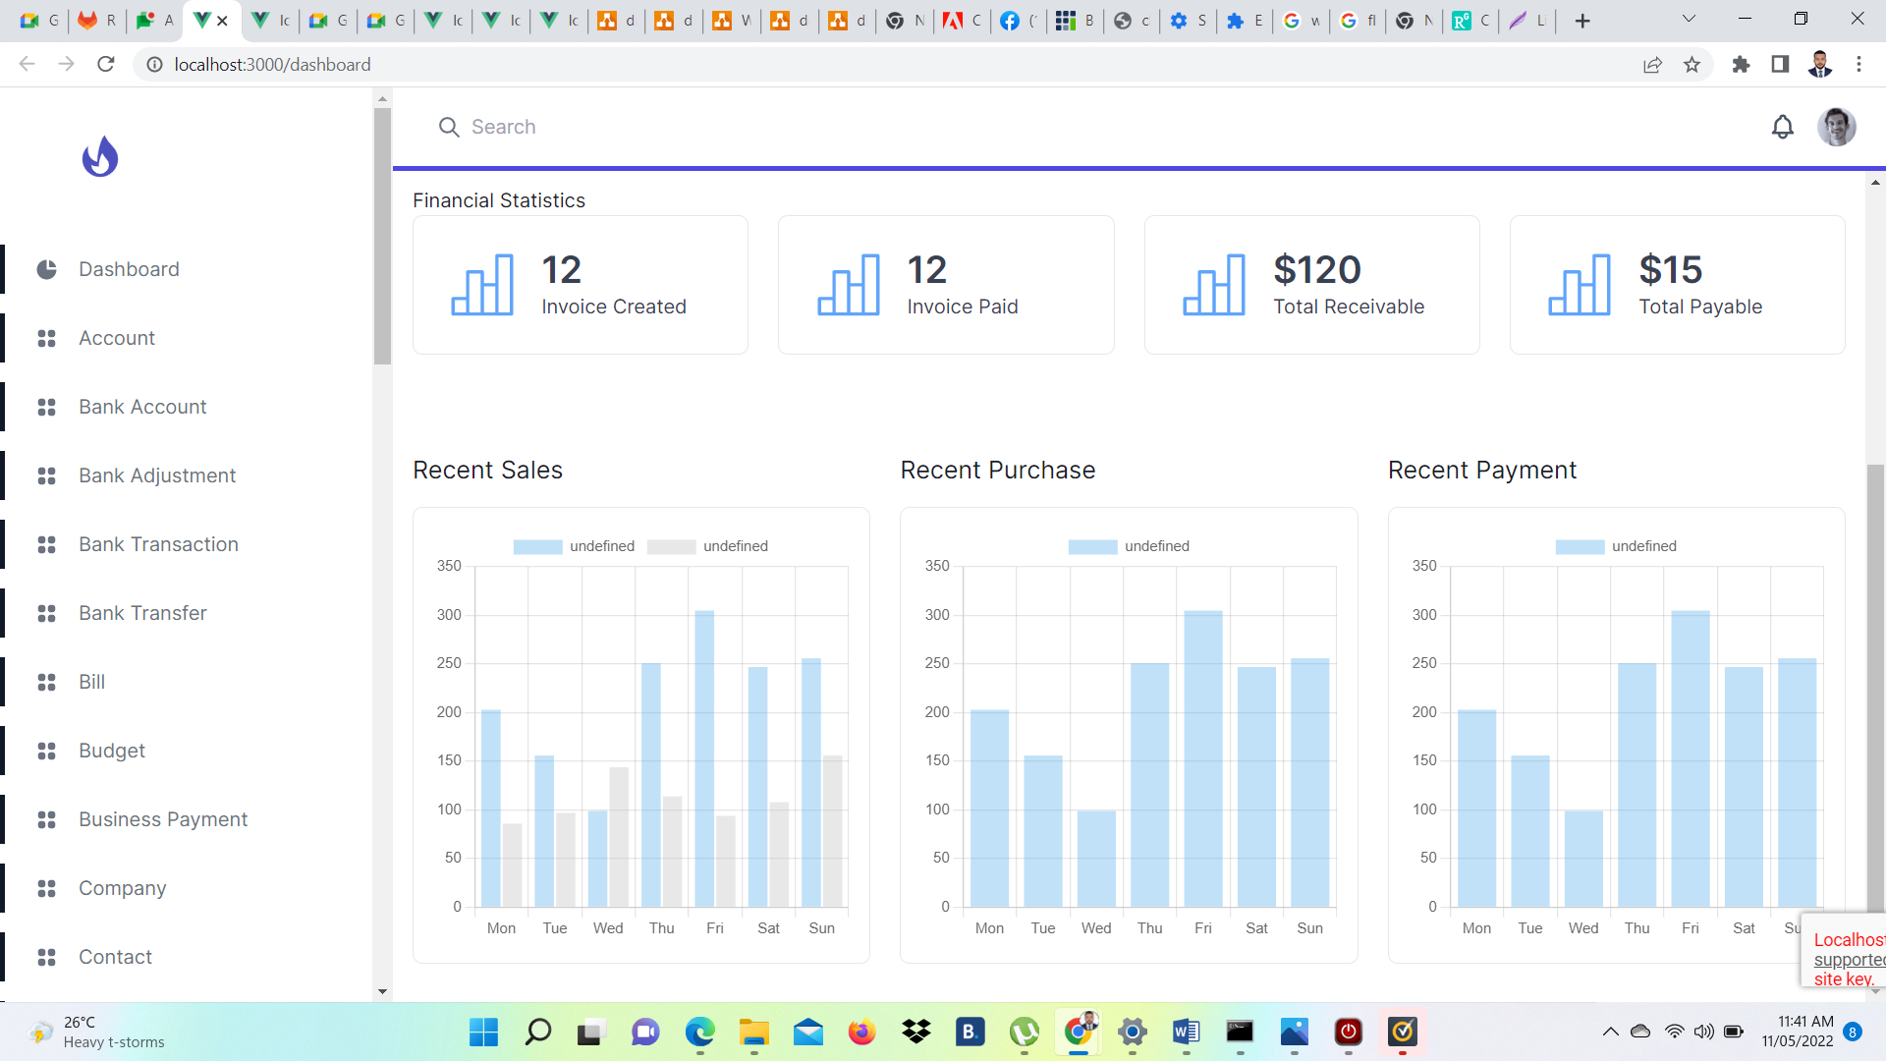

***Dashboard of Accomium***

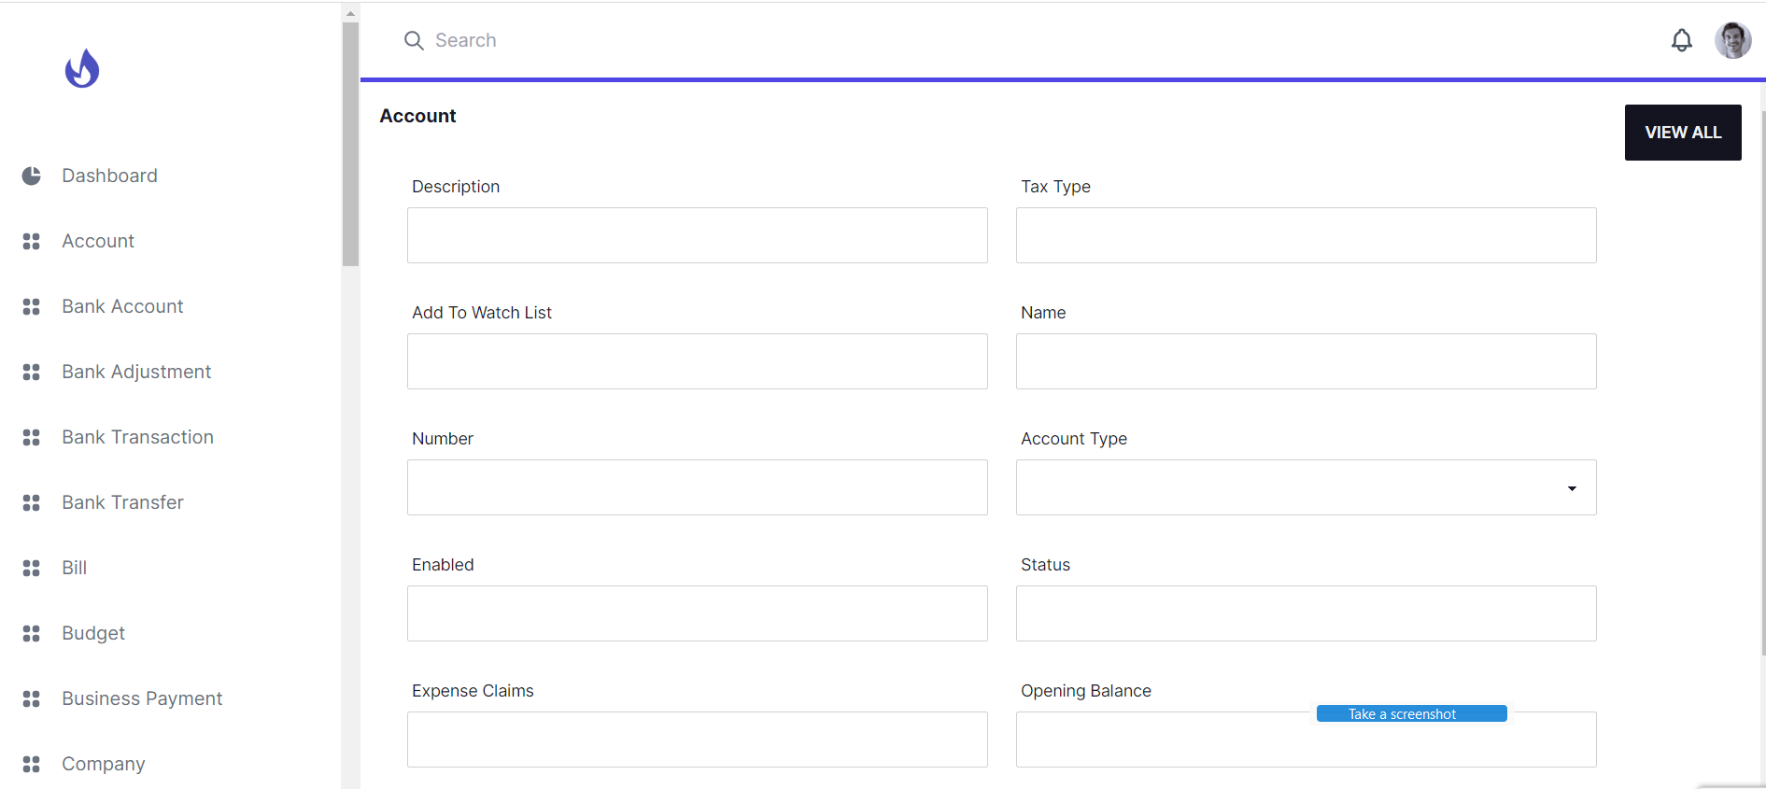

***Account Info Input Interface***

# *Project as Engineering Problem Analysis*

## *Sustainability of the Project/Work*

*The development of sustainable software has been identified as one of the key challenges within the field of Web Application. Sustainable development aims to meet show needs whereas guaranteeing supportability of common frameworks and the environment to not compromise the capacity of future generations to meet their possess needs. To keep the software more sustainable maintains of the system and user interface need to change time to time keep the function similar. This is because using the same software for a long time may reduce the modern development around us. To keep up with it, system must be developing as well as software.*

*For Sustainable,*

* *Interviewing with different stakeholders for better understand and make easy user interface product for software.*
* *Review of one or more similar projects, discussion with CEO and then*
* *Evaluation and feedback of stakeholders will help to improvement the system and software for Sustainable which is done through collaborative case study.*

## *7.2 Social and Environmental Effects and Analysis*

*To test the catalog of criteria and legitimacy of the technique, testing facility tests were done on software items within the item bunches content handling, browser, substance administration framework, and database. A comparison of computer program items inside each gathers and with the same usefulness uncovered pertinent contrasts in terms of equipment assets use and energy. Take the case of content handling: the vitality utilization of program 1 run on the same equipment to execute the standard utilization situation was about four times higher and processor utilization more than four times more noteworthy than with the comparable program 2. To keep the application working is optimum condition, we make sure it can use in minimum configuration include in our non-function properties.*

## *7.3 Addressing Ethics and Ethical Issues*

*In this era of technology trying to be someone became very easy, without knowing some- one can try to impersonate you and use your credential to do illegal or commit any crime. It became vital to keep user data securely otherwise someone can easily attack the system and take user information.*

***Fraud and Identity Theft:*** *The website does not allow any other third-party software to the database. Data are from what user provides no other information are stored.*

***Data Security:*** *Only the head developer will have access to the server and the database system. Database is secured with user name and password, without this logging information no one else can have access to the data collection.*

***No Discrimination:*** *There are no discriminate of any kind based on race, sexuality, gender, religious beliefs, color, language, political or other opinion, national or social origin, property, birth, or other status.*

# *Lesson Learned*

## *Problems Faced During this Period*

*During my internship program, I have faced lots of challenges while working on this Project.*

*Some of these are listed below:*

* + - ***New Technologies:*** *Since this was the first time, I have ever worked on a web application in an office environment I had to learn and adapt to new technologies of the company. Although acquiring the skill set was possible it became hard to apply them in real life situations.*
    - ***Keeping up to Speed:*** *After learning new technologies and putting them to use was a slow process for me initially as it was the first time, I have ever used it with an office environment. Hence, it was quite difficult to meet weekly deadlines and this slowed down the overall pace at which the application was developing.*
    - ***Identifying and Fixing Bugs:*** *Often there were bugs which were very hard to find, and even after they have been found it became a big problem to fix it. There were bugs that were so difficult to deal with that it would take a whole week to fix it.*

## *Solution of those Problems*

*Solution for those problems are listed below:*

* + - ***New Technologies:*** *In the beginning it was a difficult situation for me to adopt with new technologies. But after some days I habituate with the entire process by the help of my supervisor and support of web developer team.*
    - ***Keeping up to Speed:*** *Initially it was a slow process for me as it was the first time, I have never used it with an office environment. After some days, It became easier to maintaining work load and speed.*

***Identifying and Fixing Bugs:*** *We have project boards linked to the shared file on google chat/drive where we keep updating and we fix all the bug through team discussion and deep understanding of the code.*

# *Future Work & Conclusion*

## *Future Works*

*Accomium is the first version of the system. It has many sides for improvement. Some of them are:*

* + - *Add premium features*
    - *Add live chat system*
    - *Add video consultancy option*
    - *Add rating system for each service*
    - *Improve existing features*

## *Conclusion*

*This internship has been a very fruitful and worthy experience for me. I was able to work, hands-on, in an industry that I had no prior knowledge about. The process of transforming the rich theoretical knowledge with the practical knowledge of the industry has dawned on me and driven to seek excellence in the craft of Data Science.*

***BIBLIOGRAPHY:***

|  |
| --- |
| *"Zoho Books,"Cloud accounting system, March 2011. [Online]. Available: https://www.zoho.com/books/.* |
| *"Xero," Cloud accounting system. 2011.Available: https://www.xero.com/accountants-bookkeepers/bookkeepers/.* |
| *"FreshBooks,"web-based invoicing software, [Online]. Available: https://www.freshbooks.com/research-data-reports-library.* |

*"RecearchGate," European commercial social networking***site***for scientists and researchers to share papers, [Online]. Available:* [*https://www.researchgate.net/figure/Structure-of-outsourcing-relationship-in-cloud-based-accounting-information-systems_fig4_276510135*](https://www.researchgate.net/figure/Structure-of-outsourcing-relationship-in-cloud-based-accounting-information-systems_fig4_276510135)

*"Draw io," Free online diagramming software application for building diagramming, 4th August 2017 [Online]. Available: https://app.diagrams.net/?libs=general.*